

2929 McFarland Road Rockford, IL 61107
(South of Woodman’s near Olde Creek and Perryville)

(815) 654-2020 (815) 654-0393 Fax

WELCOME!
Thank you for allowing us to provide vision care for you.
We welcome the opportunity to be of service to you.

Enclosed is a patient information form, plus a form for listing your current medications. Please take a few minutes to complete. These forms give us vital information in providing your services and assist us with your insurance claim filing.

During your visit with us, feel free to browse in our new optical shop ~
bring in your glasses for a complimentary adjustment and cleaning!

Please bring with you to your scheduled appointment:

- Your completed Patient Information Form and a PHOTO ID.
- Your completed Medication Form which lists your current medications
and dosages.
- Your most current health insurance ID card.
- Your most current vision insurance ID card (if applicable).
- Your copayment.*
*Your insurance company requires us to collect your copayment at the time of service
(we accept cash, check or credit card).
Please note that if we must bill you for your copayment, a $20.00 administrative fee will be added.

If you have an insurance plan that requires a referral from your primary care provider, you must bring that with you in order to be seen, or you will be responsible for payment. Please note that referrals have expiration dates and limits. If you have questions regarding your health insurance coverage or co pay amount, please contact your health insurance company prior to your visit.

Kindly call us at (815) 654-2020 24-hours in advance
if you need to cancel or reschedule your appointment.

PLEASE ARRIVE 15 MINUTES PRIOR TO YOUR APPOINTMENT

Your appointment is scheduled for:

Monday Tuesday Wednesday Thursday Friday Saturday

Date: _____________________________Time: _____________ a.m. / p.m.

Eric Ericson, MD Natalya Romaniv, MD Mitul Vakharia, MD

Douglas Shumaker, O.D. Paul Hahn, O.D.
Notice:
If you are late we must reschedule your appointment

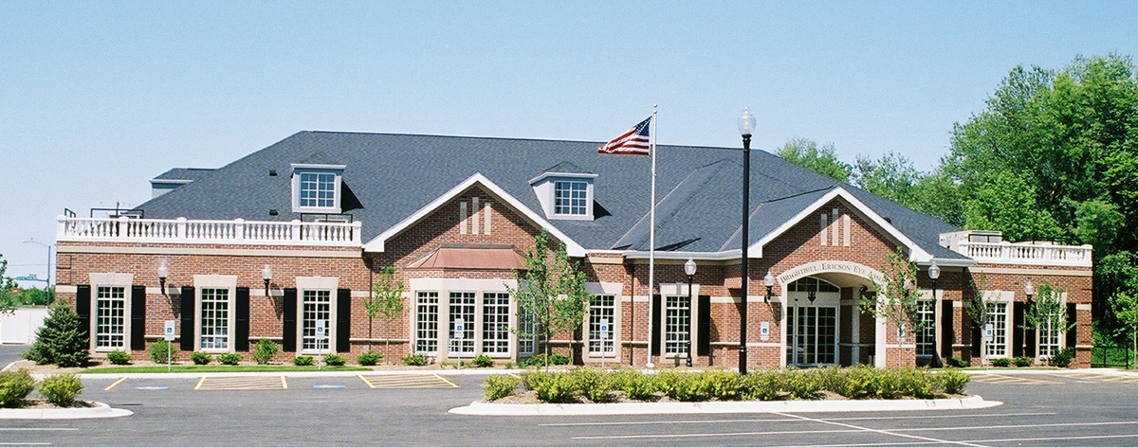

Our office is located at the corner of Olde Creek Rd. and McFarland Rd.
(South of Woodman’s Grocery Store)
2929 McFarland Rd. Rockford, IL. 815-654-2020

DRIVING EAST ON SPRING CREEK ROAD - Drive east past Mulford Road. Continue across Perryville Road (JMK Nippons will be on your left, BlackHawk Bank will be on your right). Turn left onto McFarland and continue driving past Mary’s Market, Lady Wellness, etc. We are the last building on the right before you get to Olde Creek Rd.

DRIVING WEST ON OLDE CREEK ROAD – Continue west to McFarland Rd. Turn left at the light, onto McFarland Rd. (south of Woodman’s Grocery store. Turn left into our parking lot (which is the first brick building on your left)

GOING SOUTH ON PERRYVILLE ROAD – Take a left on Olde Creek Road (at Marathon gas station). Continue to McFarland Rd (at the light) turn right. (We are the first building on the left, a brick building on the corner).

GOING NORTH ON PERRYVILLE ROAD – At Olde Creek and Perryville Rd- turn right (at the Phillips 66 gas station). Go to the next light, (McFarland Road), then turn right and we are the first brick building on the left on the corner. Our building is located on the left.

FROM I-90 – Exit 1-90 at the East Riverside Blvd. Exit. Go west on East Riverside Blvd. to McFarland Rd. (McDonalds is at the corner). Turn left on McFarland Rd. continue to Olde Creek Rd. Cross Olde Creek Rd. and our building is on the left side at the corner. We are at corner of Olde Creek Rd and McFarland Rd.

